**Difference Between Window Object & Document Object**

**Browser Object Model**

The Browser Object Model contains objects that represent the current browser window or tab. The topmost object in the BOM is the **window**object representing the window or tab or an iframe sometimes. Window object has properties like browser history, location and the device’s screen etc. In case of multi tab browser, a window object represents a single tab, but some of its properties like innerHeight, innerWidthand methods like resizeTo() will affect the whole browser window.

**Document Object Model**

When a web page is loaded, the browser creates a Document Object Model of the page. The document object represents the whole html document as a tree of Objects (HTML, HEAD, BODY, and other HTML tags). It is the root element that represents the html document.

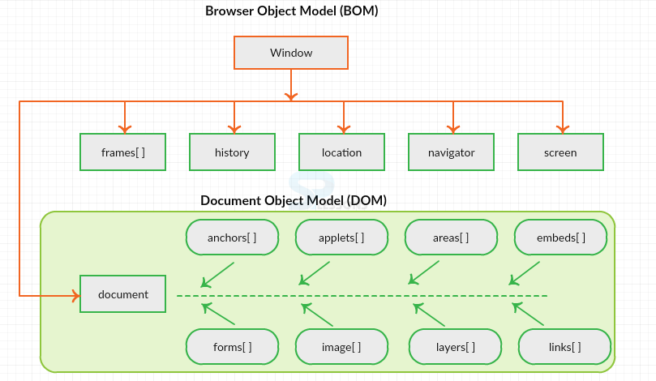

**Window Vs Object**

**Window object**: It is the top most object and outermost element of the object hierarchy. The window object is the topmost object of the DOM hierarchy. It represents a browser window or frame that displays the contents of the webpage. Whenever a window appears on the screen to display the contents of the document, the window object is created.

**Syntax:**

window.property_name;

**Document object**: Each HTML document that gets loaded into a window becomes a document object. The document contains the contents of the page. Using document object, JavaScript can modify, add and delete the HTML elements, attributes CSS styles in the page

The document object represents a web page that is loaded in the browser. By accessing the document object, we can access the element in the HTML page. With the help of document objects, we can add dynamic content to our web page. The document object can be accessed with a **window.document**or just**document.**

**Syntax:**

document.property_name;

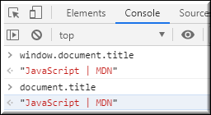

The window object represents a window/tab containing a DOM document whereas document object is property of window object that points to the DOM document loaded in that window.

You can access a document object either using window.document property or using document object directly as window is global object. In the below example, title is the property of document object.

The other major difference is that both window object and document object have properties and methods. Few method names are same in both objects but with different behavior. In the below example window.open() opens a new tab or window and document.open() creates a blank document within the window.

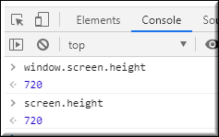

**Screen**

Screen is the window property that holds information of browser screen. It refers to screen object associated with that window **object**. Used to display screen width, height, colorDepth, pixelDepth etc

Similar to document screen can be accessed either by window.screen or screen object directly. Screen object doesn't have any methods as in window and document objects.

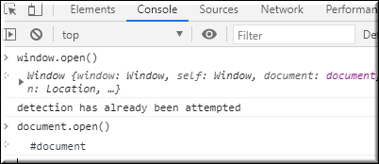

**Properties of document:**

* **activeElement**: It returns the currently active elements in the document.
* **body**: It returns the contents of the body element.
* **anchors**: It returns all <a> elements that have a name attribute.
* **baseURI**: It returns a string value that represents the base URI of the document.
* **cookie**: It returns the cookie of the current document.
* **charSet**: It returns a string, representing the document’s character encoding.
* **defaultView**: It returns the current Window Object.
* **designMode**: It is used to set documents as editable or read-only.
* **domain**: It returns the domain name of the document server.
* **doctype**: It returns the document’s doctype.
* **embeds**: It returns the collection of all embedded elements.
* **URL**: It returns the complete URL of the document.
* **forms**: It returns all the elements of the form.
* **fullScreenElement**: It returns the element that is currently present in full-screen mode.
* **title**: It returns the title element of the document.
* **head**: It returns the head element of the document.
* **links**: It returns all <area> and <a> elements that have a href attribute.
* **lastModified**: It returns the date and time of the current document that was last modified.
* **images**: It returns the collection of <img> elements in the document.
* **implementation**: It returns the DOMImplementation object associated with the current document.
* **readyState**: It returns the loading status of the current document.
* **referrer**: It returns the URI of the page that is linked to the current page.
* **scripts**: It returns all script elements present in the document.
* **strictErrorChecking**: It sets or returns whether strict error checking can be enforced on a document or not.

**Properties of the window:**

* **Closed**: It holds a Boolean value that represents whether the window is closed or not.
* **console**: It returns a reference to the console object which provides access to the browser’s debugging console.
* **defaultStatus**: It is used to define the default message that will be displayed in the status bar when no activity is carried on by the browser.
* **controllers**: It returns the XUL controller objects for the current Chrome window.
* **customElements**: It returns a reference to the CustomElementRegistry object, which can be used to register new custom elements and also get information about already registered custom elements.
* **crypto**: It returns the browser crypto object.
* [**devicePixelRatio**](https://www.geeksforgeeks.org/html-dom-window-devicepixelratio-property/): It returns the ratio between physical pixels and device-independent pixels in the current display.
* **Document**: It returns a reference to the document object of that window.
* **DOMMatrix**: It returns a reference to a DOMMatrix object, which represents 4×4 matrices, suitable for 2D and 3D operations.
* **frames[]**: It represents an array that contains all the frames of a given window.
* **DOMPoint**: It returns a reference to a DOMPoint object, which represents a 2D or 3D point in a coordinate system.
* **History**: It provides information on the URLs visited in the current window.
* **Length**: It represents the number of frames in the current window.
* **DOMRect**: It returns a reference to a DOMRect object, which represents a rectangle.
* **fullScreen**: This property indicates whether the window is displayed on full screen or not.
* **Location**: It contains the URL of the current window.
* **innerHeight**: It is used to get the height of the content area of the browser window.
* **innerWidth**: It is used to get the width of the content area of the browser window.
* **Name**: It contains the name of the referenced window.
* **Window**: It returns the current window or frame.
* **Navigator**: It returns a reference to the navigator object.
* **outerHeight**: It will get the height of the outside of the browser window.
* **outerWidth**: It will get the width of the outside of the browser window.
* **Status**: It overrides the default status and places a message in the status bar.
* **Top**: It returns a reference to the topmost window containing a frame if many windows are opened.
* **Toolbar**: It will result in the toolbar object, whose visibility can be toggled in the window.
* **Opener**: It contains a reference to the window that opened the current window.
* **Parent**: It refers to the frameset in which the current frame is contained.
* **Screen**: It refers to the screen object
* **Self**: It provides another way to refer to the current window.